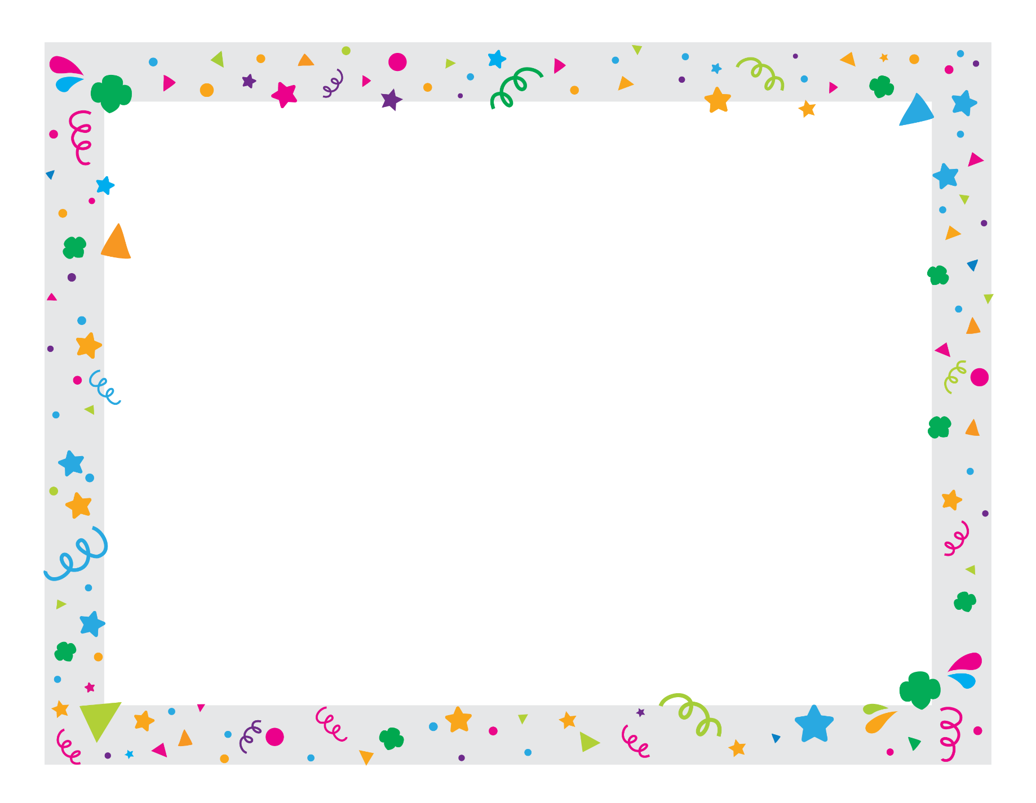

Another name block, OR:

Date Received

[Arial 8, left-aligned]

Name, Position in SU

[Town] Service Unit [###]

[Arial 8, left-aligned]

*[Sign by hand here]*

*[Sign by hand here* or *Month Date, Year]*

It’s time to embrace what you’ve learned in Girl Scouting, honor how that will forever be a part of who you are, and step into the world as a young woman of courage, confidence, and character.

**The [Town] Service Unit [###] of**

**Girl Scouts of Eastern Massachusetts congratulates**

***Name, Arial Bold 32 Italic, Center***

**for graduating from Girl Scouts and bridging to**

**Girl Scout Adult!**